Mail To: Laura Smith, 12425 W. State Road 54, Linton, IN  47441

Phone: 812-365-8567

**TOTAL ENTRY $__________________**

**Stalls @ $60 @ day ($105 Show) $__________**

**$15 refunded if you clean stall when leaving**

**GROUNDS FEE (Show from Trailer) $__________**

**Show Fees:**

**______Office Fee $30 Per Horse $__________**

**Pay office fee once per horse**

**Show Fees:**

**ONLY Arabian/Half-Arabian/Anglo-Arabian**

**_____AHA /9-90 Fee $10 Per Horse $___________**

**______AHA SEM Fee $35 @ person $__________**

**Other Fees: All Breed/AR/HA/AA**

**______Shavings x $9.00 per bag $__________**

**______Camping x $30@ day $__________**

**______Incomplete entry ($25) $__________**

**______Dressage Number Fee $__________**

**______Misc. Fee $__________**

**ENCLOSED TOTAL FEES $__________________**

**MAKE CHECKS PAYABLE TO:**

**IHAHC, INC.**

**OWNER**: (as it appears on reg. papers or contract)

Name: __________________________________________ AHA #_________________

Address: _____________________________________

City, State, Zip:___________________________________Phone #_________________

e-mail:__________________________________________________________________

**TRAINER**: ______________________________________ AHA #_________________

Address: _____________________________________

City, State, Zip:___________________________________ Phone #_________________

E-mail:________________________________________ Walk/Trot Rider’s Birthday

(Your entry Acknowledgment will be sent via e-mail with an attachment)

________________________________

Amateur Owner Relationship to Horse Owner: ____________________________________

STABLE WITH______________________________________________________________

(Send request for joint stabling in the same envelope)

Emergency Phone: _________________

**CREDIT CARDS ARE NOT ACCEPTED** PAGE 13

**PLEASE TYPE OR PRINT/ONLY ONE OWNER ONE HORSE PER ENTRY FORM**. All entries must be complete. Enclose correct fees, copies of horse registration papers, purchase contract (if applicable), USEF/EC amateur certification, and AHA membership cards for each rider, driver, handler, and owner.

|  |  |  |  |  |  |  |  |  |  |  |  |  |  |  |  |  |  |  |
| --- | --- | --- | --- | --- | --- | --- | --- | --- | --- | --- | --- | --- | --- | --- | --- | --- | --- | --- |
|  | Name of Horse | | | | Reg. No. | | | | DOB | | | | Sex | | Color | Height | | Sweepstakes  ❑ Yes ❑ No |
| Sire | | | | Dam | | | | | Horse USEF ID# | | | | | | | | Horse USDF # |
| *Rider/driver/*  *handler # 1* | Class Numbers | |  | |  |  | | | |  | | | | |  | | | Total Fees  $ |
| *Entry Fee* | | $ | | $ | $ | | | | $ | | | | | $ | | |
| *#1Rider Name* | | | | | DOB: MM/DD/YY | | Amateur  Yes No | | | | | *Relationship to horse owner* | | | | | | |
| AHA # | | USEF/EC# | | | USDF # | | | | | | | | | *US Citizen Yes No* | | | | |
| Address | | | | City | | | | | | | State | | | | | | Zip | |
| Address | | | | City | | | | State | | | | | | | | | Zip | |
| *Rider/driver/*  *handler # 2* | Class Numbers | |  | |  |  | | | |  | | | | |  | | | Total Fees  $ |
| *Entry Fee* | | $ | | $ | $ | | | | $ | | | | | $ | | |
| *#2 Rider Name* | | | | | DOB: MM/DD/YY | | Amateur  Yes No | | | | | *Relationship to horse owner* | | | | | | |
| AHA # | | USEF/EC# | | | USDF # | | | | | | | | | *US Citizen Yes No* | | | | |
| Address | | | | City | | | | | | | State | | | | | | Zip | |

**AHA VALUE SHOW HOOSIER HORSE CLASSIC**

**July 8 & 9, 2023**

**PRE-ENTRIES CLOSE June 19, 2023**

Each person signing this entry form acknowledges that he/she has read the front and reverse side of this entry form and agrees to the applicable terms, conditions, waivers and consent as set forth herein. Each person agrees that the information is accurate to the best of his/her knowledge. All OWNERS, RIDERS, DRIVERS, & HANDLERS MUST SIGN ON THE BACK. Minor entrants must also have parent/guardian signatures(s) on the back.

**\*\*\* PHOTO COPIES REQUIRED of all Arabian/Half-Arabian/Anglo-Arabian Horse Reg. Papers, Proof of Ownership (if applicable), AHA Competition Amateur cards (if applicable), for all owners/riders/trainers or PAY INCOMPLETE ENTRY FEE\*\*\***

**NO BLANK CHECKS ACCEPTED!!!**

**AHA ENTRY AGREEMENT**

I have read the rules concerning competitions as printed in the Arabian Horse Association® (AHA®) Handbook and Directory and agree to be bound by and subject to those Rules.

AHA ASSUMPTION OF RISK, RELEASE AND INDEMNIFICATION

**This document waives very important legal rights. Read it carefully before signing.**

In consideration for AHA permitting me to participate in this Competition, and by signing the entry blank, I agree as follows:

**I AGREE** that I choose to participate voluntarily in this Competition, as a rider, driver, handler, leasee, owner, agent, coach, trainer, junior exhibitor, or as a parent or guardian of a junior exhibitor. **I AM FULLY AWARE AND ACKNOWLEDGE THAT HORSE SPORTS AND PARTICIPATION IN THIS COMPETITION INVOLVE SERIOUS RISK OF HARM INCLUDING, BUT NOT LIMITED TO, RISKS OF ACCIDENT, SERIOUS BODILY INJURY, INCLUDING DEATH, BROKEN BONES, HEAD INJURIES, TRAUMA, PAIN AND SUFFERING, AND PROPERTY DAMAGE. I ASSUME ALL RISKS OF HARM TO ME, MY HORSE OR MY PROPERTY.**

**I AGREE** as a Horse Show Participant (or Parent/Guardian of Participant if a minor) to waive all claims which may otherwise arise from, including but not limited to infectious bacteria, viruses, fungi/mold, parasites or other agents which may be present at the Horse Show (and most other outdoor locations) and can cause infection in humans and animals.

**I AGREE** for myself, my heirs, executors, administrators, successors and assigns **to release** AHA, the Competition, the facilities leased by the Competition and the owner(s) of the facilities, and all of their respective officers, officials, directors, employees, agents, personnel, volunteers, affiliated organizations and insurers (collectively, the "Released Parties") from any and **all claims for damage, loss, or injury to myself, other persons, horses or other property** belonging **to me to the fullest extent** permitted by law that arises out of or relates in any way to the Competition and my participation in the Competition **INCLUDING, BUT NOT LIMITED TO, DAMAGES, LOSS, OR INJURY RESULTING FROM ANY ACTS, FAILURE TO ACT, NEGLIGENCE OR NEGLECT OF OTHER ENTRANTS, THE RELEASED PARTIES, THEIR CONTRACTORS OR INVITEES**, as well as for theft, vandalism, fire, other casualty damage, or damage arising out of any defects in the premises.

**I AGREE** to **indemnify** and **hold harmless** (that is pay all losses, damages, attorney’s fees and costs of) the Released Parties from and against any and all claims, demands, penalties, actions, losses, costs, damages, injuries, liabilities and obligations (including attorney’s fees) of whatsoever kind and nature, which may be asserted against or incurred by any of them as a result of (1) my participation in the Competition or (2) any act, failure to act, or neglect (a) by me, my agents, employees, riders, handlers, trainers, coaches, drivers, contractors or invitees, or (b) by any animal owned or exhibited by me or in my custody or control.

**I AGREE** **and represent** that I am qualified and eligible to enter and/or participate in the Competition, and every horse I am entering is qualified and eligible as entered.

**I AGREE** **to accept AS FINAL** any decision of AHA, the Show Commission or Show Officials concerning my qualification or the qualification of my horse to enter the Competition or any results of the Competition, except to the extent that the Rules of AHA, the Competition, Equestrian Canada or U.S. Equestrian Federation permit a protest or hearing of such decisions. Should a hearing be requested, **I agree to accept AS FINAL** the decision of the particular hearing body. **I agree to release, hold harmless** and **not to sue** AHA, the Competition Sponsor, their officers, directors, employees, volunteers or members concerning any decision of AHA, the Competition, its Show Commission, Show Officials or any hearing body that relates to my qualifications or my horse(s)’ qualifications to enter the Competition or any results of the Competition.

**I AGREE** that AHA has the sole right to control, sell, supervise or give away (or assign to others the right to do so) the exclusive rights to broadcast, televise, reproduce, transmit and disseminate all or part of this event, and I agree that AHA may use or assign, in any way AHA sees fit, photographs, films, videos, audios, cablecasts, or other likenesses of me and my horse taken during the course of the Competition for the promotion, coverage or benefit of the Competition or AHA. Those likenesses shall not be used to advertise a product and they may not be used in such a way which implies endorsement of any company, product, product category or service. I hereby expressly and irrevocably waive and release any rights in connection with such use, including any claim to compensation, invasion of privacy, right of publicity, or to misappropriation. By signing below as a parent or guardian of a junior exhibitor, I consent to the child’s participation and agree to all of the above provisions, and further agree to assume all of the obligations of this AHA Assumption of Risk, Release and Indemnification personally and on behalf of the child.

**This AHA Assumption of Risk, Release and Indemnification** is governed by the Laws of the State of Colorado and is intended to be interpreted as broadly as possible. I agree that exclusive jurisdiction and venue (place) for any legal action against AHA, its officers, directors, employees, volunteers or agents shall be in the local district courts or the federal court of the State of Colorado. If any part of this agreement is determined to be unenforceable, all other parts shall remain in effect.

**RIDER/DRIVER/HANDLER/VAULTER/LONGEUR (mandatory) OWNER/AGENT (mandatory)**

#1 Signature: _____________________________________________ #1 Signature: ____________________________________________

Print Name: ____________________________________________ Print Name: ____________________________________________

#2 Signature: _____________________________________________ #2 Signature: ____________________________________________

Print Name: ____________________________________________ Print Name: ____________________________________________

#3 Signature: _____________________________________________ #3 Signature: ____________________________________________

Print Name: ____________________________________________ Print Name: ____________________________________________

**TRAINER (mandatory) COACH (mandatory)**

Signature: _____________________________________________ Signature: _____________________________________________

Print Name: ____________________________________________ Print Name: ____________________________________________

Parent/Guardian Signature: (Required if Rider/Driver/Handler/Vaulter/Longeur is a minor)_______________________________________________

Print Parent//Guardian Name:________________________________Emergency Contact Phone No._____________________________PAGE 14

**DRESSAGE DIVISION**

Open to All Breeds & Purebred Arabians and Half-Arabian/Anglo-Arabians of at least 36 months of age at the time of the competition.

The Dressage arenas consist of one 20m x 60m sand and fiber competition arenas. Large sand and fiber warm-up rings. One 20m x 40m sand competition arena.

All dressage horses must wear their assigned bridle tag number while in the dressage areas. Failure to comply will result in elimination from the remainder of the dressage competition. The **2023** USEF Dressage Tests will be used.

Classes will not necessarily run in prize list order. When assigning riding times, every attempt will be made to avoid scheduling conflicts with other classes in the show, if the show committee is advised of such conflicts when entries are made.

Entries will be accepted on a first-come, first-served per class basis. Entries will close on **June 19, 2023** **There will be no post entries accepted in Dressage except to fill scratches. Because of this, Dressage exhibitors who have failed to notify the show office of their intent to show in Dressage at least 30 minutes prior to their first ride of the show will have their rides released to the scratch waiting list.** They will also be assessed a “no show” fee for each ride.

Ride times for Sunday will be e-mailed when available **only by request** after **June 19.**

**WDAA will use the 2022 WDAA tests.**

The management of Hoosier Horse Classic will do all things to maintain a safe environment with the Covid-19 issue.

Masks may to be worn when you are in the company of someone else of less than 6 feet.

Hand sanitizer is to be used as often as needed.

No groups of more than 10. Keep safe distances at all times.

No more than 2 assistants per horse in the paddock.

Temperatures may be taken every morning of all show personnel. Any temperature above 100.4 is to be denied access to the facility.

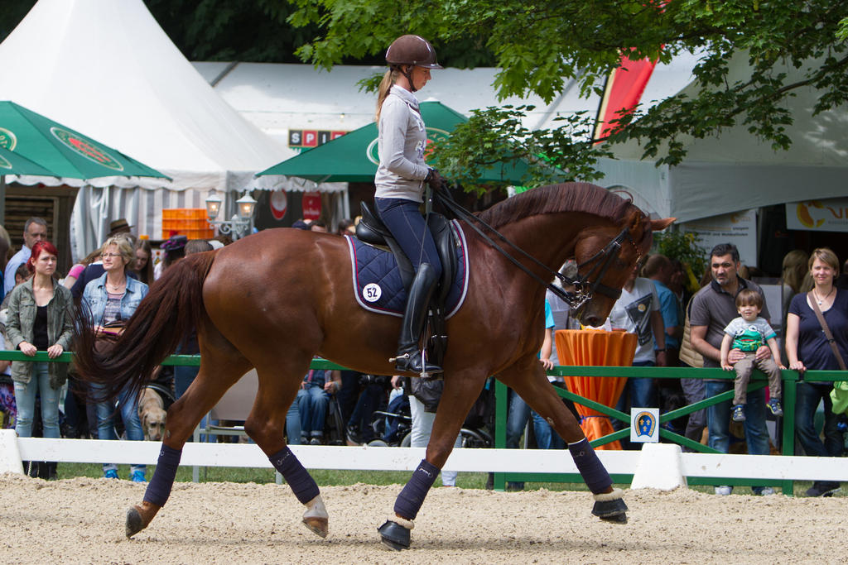

PAGE 15